**SQL ASSIGNMENT ON EMPLOYEES**

**AND**

**DEPARTMENTS OF A COMPANY**

**Even Semester**

**Semester-II**

**MA Applied Economics**

**Submitted by: Submitted To**

Name: Anirban Bhowmick Mr. Abdul Majed Raja

Roll Number: 2237003 Christ University

Subject Name: Business Analytics with R

Subject Code: MEC201

Date of Submission 29.03.2023



**Department of Economics**

**School of Social Sciences**

**Christ University**

**Bangalore, Central Campus**

**DATA**

**EMPLOYEES.NAME**

|  |  |  |  |
| --- | --- | --- | --- |
| ID | NAME | AGE | DEP |
| 1 | ALINE | 25 | 1 |
| 2 | BOB | 30 | 2 |
| 3 | CHARLIE | 35 | 2 |
| 4 | DAVID | 40 | 3 |
| 5 | EVE | 45 | 3 |
| 6 | FRANK | 50 | 3 |

**DEPARTMENTS.NAME**

|  |  |
| --- | --- |
| 1 | SALES |
| 2 | MARKETING |
| 3 | ENGINEERING |

**QUESTIONS-**

1. Write a SQL query to display the names and ages of all employees in the “employees” table.

Ans-

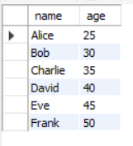

Output-

1. 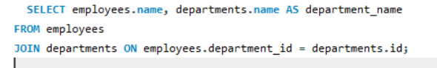Write a SQL query to display the names and departments of all employees in the “employees” table.

Ans-

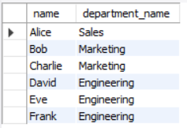

Output-

1. Write a SQL query to display the names and ages of all the employees who work in the “Engineering” department.

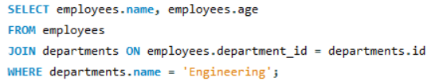Ans-

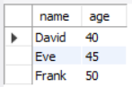 Output-

1. Write a SQL query to display the names of all departments along with the total number of employees in each department.

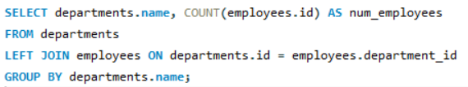Ans-

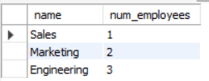Output-

1. Write a SQL query to display the names of all employees who work in the same department as “Charlie”.

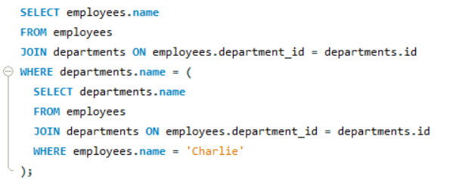Ans-

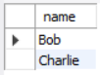 Output-

1. Write a SQL query to display the names and ages of all employees who are older than 35.

Ans-

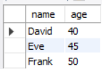 Output-

1. Write a SQL query to display the names and ages of all employees who work in the “Sales” or “Marketing” department.

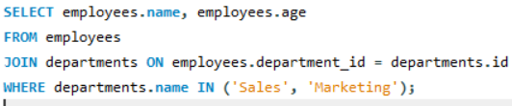Ans-

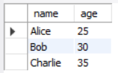 Output-

1. Write a SQL query to display the names and ages of all employees who work in the “Engineering” department and are older than 40.

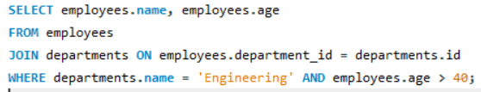Ans-

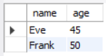 Output-

1. Write a SQL query to display the names of all departments along with the total number of employees in each department, sorted by the number of employees in descending order.

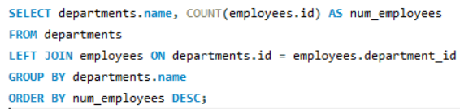Ans-

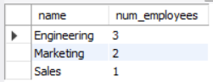 Output-

1. Write a SQL query to display the names and ages of all employees who work in the same department as “Bob” and are younger than 35.

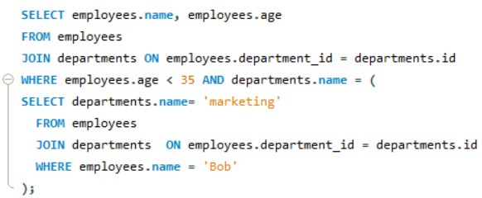Ans-

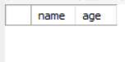 Output-